Cognizant Deepskilling: Algorithms and Data Structures

Exercise 2: E-commerce Platform Search Function
Scenario: You are working on the search functionality of an e-commerce platform. The search needs to be optimized for fast performance.

Product.java
public class Product implements Comparable<Product> {
private int productId;
private String productName;
private String category;
public Product(int productId, String productName, String category) {
this.productId = productId;
this.productName = productName;
this.category = category;
}
public int getProductId() { return productId; }
public String getProductName() { return productName; }
public String getCategory() { return category; }
@Override
public int compareTo(Product other) {
return Integer.compare(this.productId, other.productId);
}
@Override
public String toString() {
return "Product{" + "id=" + productId + ", name='" + productName + "', category='" + category + "'}";
}
}

SearchPlatform.java
import java.util.Arrays;
public class SearchPlatform {
// Linear Search: O(n) time complexity
public static Product linearSearch(Product[] products, int targetId) {
for (Product p : products) {
if (p.getProductId() == targetId) {
return p;
}
}
return null;
}
// Binary Search: O(log n) time complexity
public static Product binarySearch(Product[] products, int targetId) {
int left = 0;
int right = products.length - 1;
while (left <= right) {
int mid = left + (right - left) / 2;
if (products[mid].getProductId() == targetId) {
return products[mid];
}
if (products[mid].getProductId() < targetId) {
left = mid + 1;
} else {
right = mid - 1;
}
}
return null;
}
public static void main(String[] args) {
Product[] inventory = {
new Product(105, "Laptop", "Electronics"),
new Product(101, "Smartphone", "Electronics"),
new Product(109, "Desk Chair", "Furniture"),
new Product(102, "Coffee Maker", "Appliances"),
new Product(107, "Headphones", "Electronics")
};
System.out.println("--- Linear Search ---");
Product foundLinear = linearSearch(inventory, 109);
System.out.println("Found (109): " + (foundLinear != null ? foundLinear : "Not Found"));
System.out.println("\n--- Binary Search ---");
Arrays.sort(inventory); // Must be sorted before binary search
System.out.println("Inventory sorted by ID.");
Product foundBinary = binarySearch(inventory, 107);
System.out.println("Found (107): " + (foundBinary != null ? foundBinary : "Not Found"));
}
}
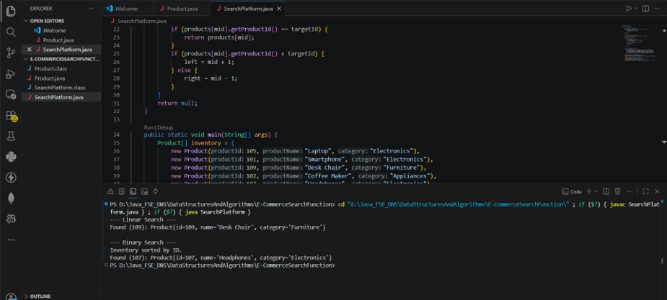
Exercise 7: Financial Forecasting
Scenario: You are developing a financial forecasting tool that predicts future values based on past data using recursive algorithms.

FinancialForecasting.java
public class FinancialForecasting {
// Recursive method to calculate future value
// Time Complexity: O(n) where n is the number of periods
public static double calculateFutureValue(double presentValue, double growthRate, int periods) {
// Base Case
if (periods <= 0) {
return presentValue;
}
// Recursive Case
return calculateFutureValue(presentValue * (1 + growthRate), growthRate, periods - 1);
}
public static void main(String[] args) {
double presentValue = 10000.0;
double annualGrowthRate = 0.05; // 5%
int years = 10;
System.out.println("--- Financial Forecasting ---");
System.out.println("Present Value: $" + presentValue);
System.out.println("Annual Growth Rate: " + (annualGrowthRate * 100) + "%");
System.out.println("Years to forecast: " + years);
double futureValue = calculateFutureValue(presentValue, annualGrowthRate, years);
System.out.printf("\nPredicted Future Value: $%.2f\n", futureValue);
}
}
